Assessment Schedule – 2013
Mathematics and Statistics: Apply probability methods in solving problems (91267)
Evidence Statement
Achievement | Achievement with Merit | Achievement with Excellence
Apply probability methods in solving problems must involve using a range of appropriate methods, demonstrating knowledge of probability concepts and terms, and communicating using appropriate representations. | Apply probability methods, using relational thinking, in solving problems must involve one or more of:  - selecting and carrying out a logical sequence of steps  - connecting different concepts or representations  - demonstrating understanding of concepts  - and relating findings to a context or communicating thinking using appropriate statements. | Apply probability methods, using extended abstract thinking, in solving problems must involve one or more of:  - devising a strategy to investigate or solve a problem  - identifying relevant concepts in context  - developing a chain of logical reasoning  - and where appropriate, using contextual knowledge to reflect on the answer.

Evidence Statement
ONE | Expected Coverage | Achievement |  | Achievement with Merit |  | Achievement with Excellence
NØ = No response; no relevant evidence.
N1 = a valid attempt at ONE question.
N2 = ONE question demonstrating limited knowledge (1u)
A3 = TWO of u.
A4 = THREE of u.
M5 = ONE of r.
M6 = TWO of r.
E7 = ONE of t, with minor errors ignored.
E8 = 2 of t.
(a) (i) | P(AA wins after 2 rounds)  = ½ × ½ =1/4 |  | CAO
(a) (ii) | P(3 games)  = P(ABA wins or ABB or BAA or BAB)  =½ × ½ × ½ + ½ × ½ × ½  + ½ × ½ × ½ + ½ × ½ × ½  = ½ |  | CAO | Correct answer with working shown.
(b) (i) | P(AA wins or ABA or BAA)  = ¾ × ¼ + ¾ × ¾ × ¾ + ¼ × ¼ × ¾  = 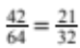 (= 0.65625) |  | Gets a partial answer, with at least one of the branches involving 3 games correct. | Correct or equivalent answer with working shown.
(b) (ii) | 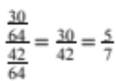 (= 0.71429) |  | Finds 30/64. | Correct or consistent answer.
(b) (iii) | Probability (team A wins) is 42/64, and P(team B wins ) = 22/64  So relative risk of team A winning compared to team B winning is  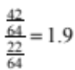  As this is almost 2 it is true that team A is almost twice as likely to win the series as team B. |  |  | Consistent answer using both probabilities. | Answer to question with full explanation.
(c) | P(A wins in 3 games) =  P(ABA or BAA) =  p³ + p(1 – p)²  P( B wins in 3 games) =  P(BAB or ABB) =  (1 – p)³ + (1 – p)p²  So relative risk =  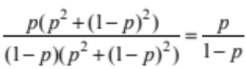  ie Team A is 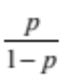 times more likely to win than Team B. |  |  | Finds probability of A or B winning correctly in 3 games. | Correct answer.

TWO | Expected Coverage | Achievement | Achievement with Merit | Achievement with Excellence
NØ = No response; no relevant evidence.
N1 = a valid attempt at ONE question.
N2 = ONE question demonstrating limited knowledge (1u)
A3 = TWO of u.
A4 = THREE of u.
M5 = ONE of r.
M6 = TWO of r.
E7 = ONE of t, with minor errors ignored.
E8 = 2 of t.
(a)(i) | P(113 < X < 120) = 0.25162  25162 / 100 000  GC  0 < Z < 0.6796 | CAO
(ii) | P(X < 115) = 0.57698  So expected number = 719 × 0.57698  Expected number of students in school is 414 or 415. | Probability calculated correctly, | Finds expected number of students correctly.  Accept, 414 or 415
(iii) | P(X > 110) = 0.61457  Probability both students BP over 110 = 0.61457² = 0.3776 | Probability BP over 110 correctly calculated. | Correct answer.
(iv) | P(X > 126.2) = 0.10  Inverse Normal GC.  So minimum blood pressure is 126.2 mm Hg.  Or P(Z > 1.2815) = 0.10  (X – 113) / 10.3 = 1.2815  X = 113 + 10.3 × 1.2815  = 126.2 | Finds Z correctly | Finds X =126.2 | Correct written interpretation
(b)(i) | 26 / 40 = 13 / 20 (= 0.65) | CAO
(ii) | (All the values except for one are over 113 mm Hg, which is the original mean. The whole distribution seems to have shifted to the right and) the mean blood pressure is therefore higher. It now looks skewed to the right, or ignoring these two high values approximately normal with a higher mean. However it is a small class size compared to all the students in a New Zealand school.  Or comment that originally approx. 42.3% lay between 110 and 122 and now it is 26 / 40, which is 65%. | Mentions one valid point in context | Discusses shift in values and higher mean in context.
(c) | P(X > 124 ) = 0.33333  Z = 0.43073  (124 – ) / 9.8 = 0.43073   = 124 – 9.8 × 0.43073   = 119.78  So new mean is 119.78 mm Hg (1dp) |  | Finds Z correctly but makes mistakes and then consistently worked out. | Must show the value of Z. Correct answer and interpretation in context using correct terms

THREE |  | Expected Coverage | Achievement | Achievement with Merit | Achievement with Excellence
NØ = No response; no relevant evidence.
N1 = a valid attempt at ONE question.
N2 = ONE question demonstrating limited knowledge (1u)
A3 = TWO of u.
A4 = THREE of u.
M5 = ONE of r.
M6 = TWO of r.
E7 = ONE of t, with minor errors ignored.
E8 = 2 of t
(a)(i) | 8825 / 10300 = 0.8568  (353 / 412) |  | Correct proportion or decimal.
(ii) | 1675 / 10300 = 0.16  (67 / 412) |  | Correct answer or equivalent.
(iii) | 1139 / 1339 = 0.8506 or 85% |  | Correct decimal or fraction. | Percentage.
(iv) | 1139 / 1475 = 0.7722 or 77% |  | Correct numerator. | Correct answer.
(b) | P(test positive) = have disease and test positive or don’t have disease and test positive  = 0.01 × 0.95 + 0.99 × 0.1  = 0.1085  P(have disease) = P(have disease and test positive) / 0.1085  = 0.0095 / 0.1085  = 0.0876  See tree diagram or 2-way table below  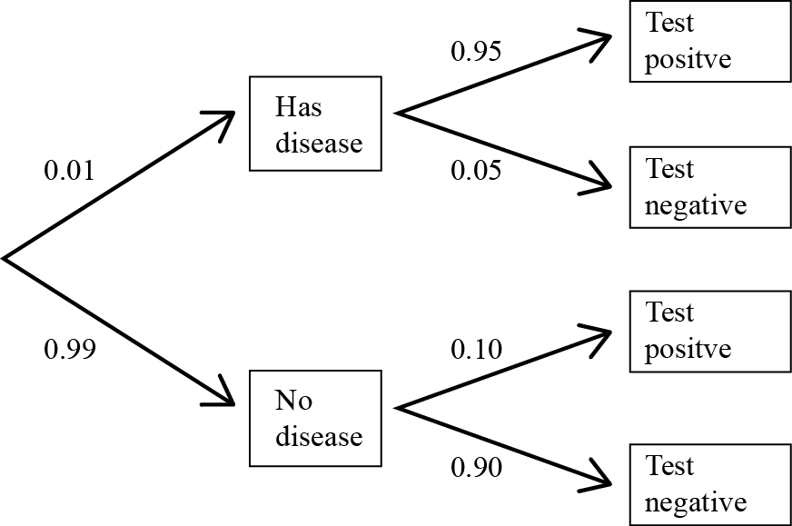  OR using a table  Probability (test positive) = 1085/10000  Probability (person with positive test had disease) = 95 / 1085  = 0.0876 |  | Calculates one part, numerator or denominator correctly. | Finds probability by dividing into two parts on bottom but makes one error. | Correct answer.
   | Test positive | Test negative | Total
  Did not have disease | 990 | 8910 | 9900
  Have disease | 95 | 5 | 100
  Total | 1085 | 8915 | 10 000
(c) | The systolic BP is more spread out from 85 to 245 mm Hg. The highest value/mode appears to be around 130 mm Hg and the distribution is skewed to the right with more higher values. The mean is therefore higher than 130 mm Hg. A large percentage of the values are between 115and 165 mm Hg. The range is 160 mm Hg.  The diastolic BP follows an approximate normal distribution. It has a mean / median around 85 mm Hg and is almost symmetrical. The values are from 50 to 130 mm Hg. So the range is 80 mm Hg and the standard deviation about 14 mm Hg.  Systolic blood pressures are seen to be higher than diastolic blood pressures. |  | General statements about the graphs. | Statement giving some values and comparisons between both distributions on 2 / 3 of centre, shape and spread. | Detailed statement with values giving comparisons with all 3 of centre, shape and spread, using the correct terms. Either range or standard deviation accepted.

Judgement Statement
 | Not Achieved | Achievement | Achievement  with Merit | Achievement  with Excellence
Score range | 0 – 8 | 9 – 14 | 15 – 19 | 20 – 24

